**Distribution plot:**

**Code:**

sns.distplot(dataset["column name"]) 🡪 sns.distplot(dataset["ssc_p"])

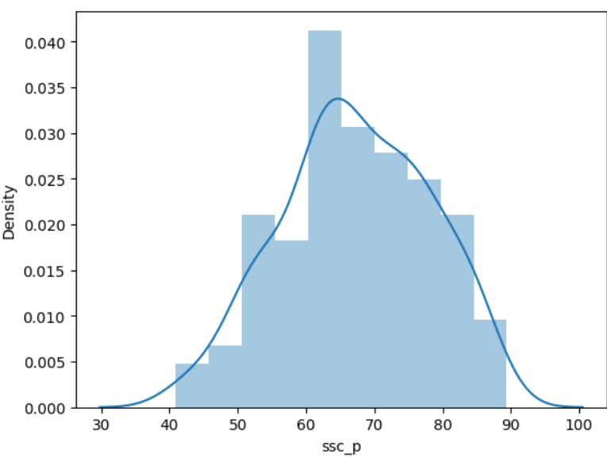

**Note**

* Distplot function is type of graph used in univariate analysis
* It does the visualisation through histogram
* The above graph explains the level of density and mark range obtained in the exam
* Density curve exists as per the score

**Normal Distribution Function:**

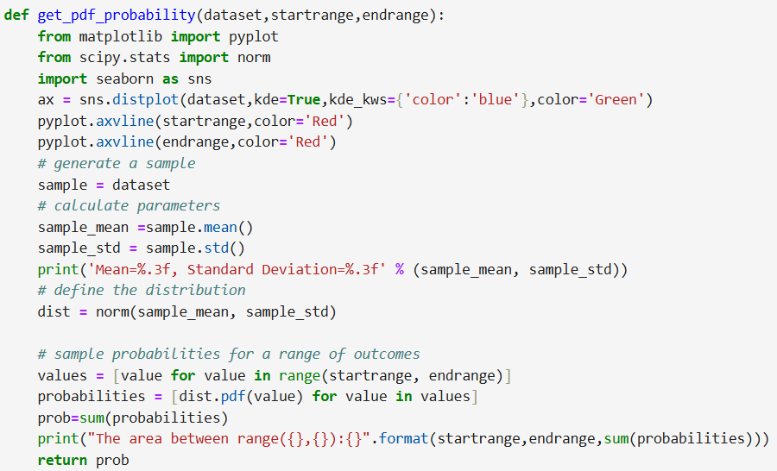

**Note:**

* The probability can be measured using the get_probability function defining the range needed
* If the same start and end range value given, there is no density defined so it becomes zero as per graph



* Needed libraries need to be loaded for the calculation



* Distplot function created with kde and it means Kernel Density Function which determines the bell curve in the graph and the color can be determined.
* The axes vertical line with start and end color can be defined and the graph is plotted as per the code

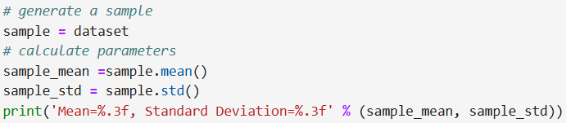

* The distribution can be calculated using mean and standard deviation



* The Scipy stats norm is used to get the mean and standard deviation from the plot
* The distribution pattern learned as an outcome

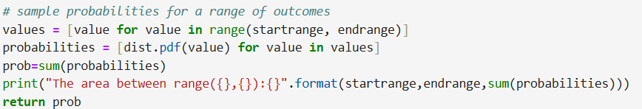

* The values are calculated using inliner
* For loop used in a unique way to make it more compact (single line)
* Summation value calculated with the probability

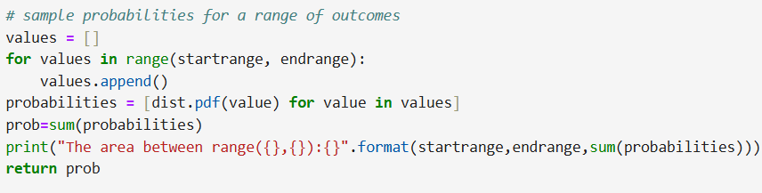

* Normal used for loop defined in 3 lines.

**Standard Normal Distribution Function:**

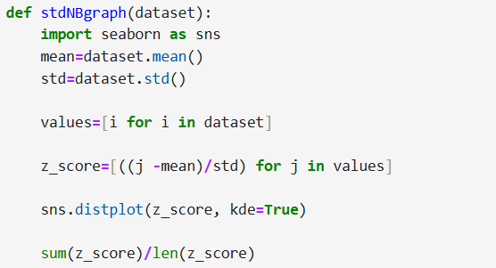

**Note:**

* Mean and standard deviation need to be find out
* The value passed is converted into a list
* Validating with the known formula Z=(x- μ(mean))/ σ(std deviation))
* Use distplot for displaying the graph